GIT AND GITHUB:-

\*It is a version control system(it can saves changes in a file).

\*It is used to track the changes.

\*It is used to manages the files.

Commands:-

1. First we want to allocate the username and email by-

get config --global user.name “Harsh”

get config --global user.email [“abc@gmail.com”](mailto:\“abc@gmail.com\”)

1. Than initialize the folder to empty git repository

git init



1. Than add a file into the staging area

git add test.html and check the status of a file it is committed or not

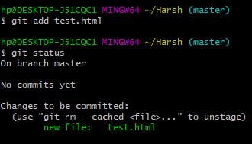

1. Than commit the changes

git commit -m “initial commit”

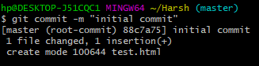

(Note :- git commit -a= will commit without going to staging area.)

1. Than print the logs

git log

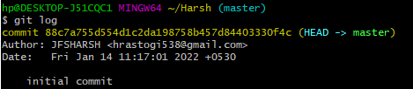

1. To create a new branch

git branch “branch name”

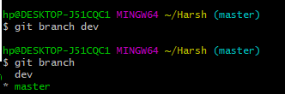

1. To move to another branch

git checkout dev



1. Than we create a another branch and merge it

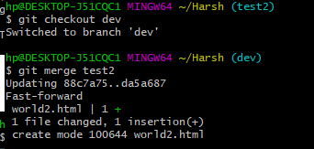

Github - It is a cloud based hosting service that lets you manage get repositories.

To add into the repository we want to push the repository to our locally to github

(i)git remote add origin https://github.com/JFSHARSH/https-github.com-HarshRastogi.git

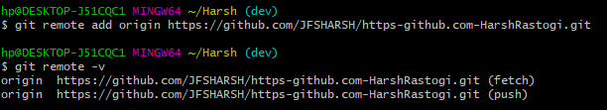

(ii)git branch -M main

(iii) git push -u origin master

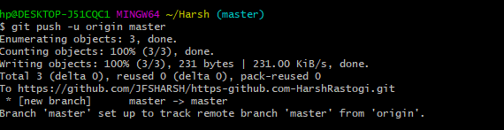

After these successfully pushed to the github account

GIT WORKFLOW:

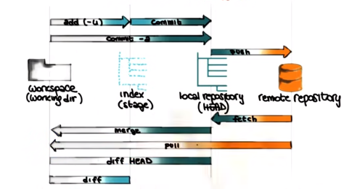

Some more commands:-dfbn

1. To check which branches are merge -

git branch --merged  
2) To delete the branch

git branch -d “branch name”

3)To check the difference which are made

git diff